## Major Update of Foundation Level Curriculum

iSAQB Foundation Level Working Group   
(Dr. Gernot Starke, group lead)

May 3rd 2024

The upcoming (April 2025) release of the Foundation Curriculum will be a major structural update and will contain many more structural changes than any previous release.

This document shall give training providers and trainers a brief overview of the schedule of these changes.

In case you are interested in structural and content-related details, please checkout our public Github repository: <https://github.com/isaqb-org/curriculum-foundation>

You can also follow our Kanban-board: https://github.com/orgs/isaqb-org/projects/7,

The following diagram gives a brief overview, the table below explains the milestones with their respective due-dates.

[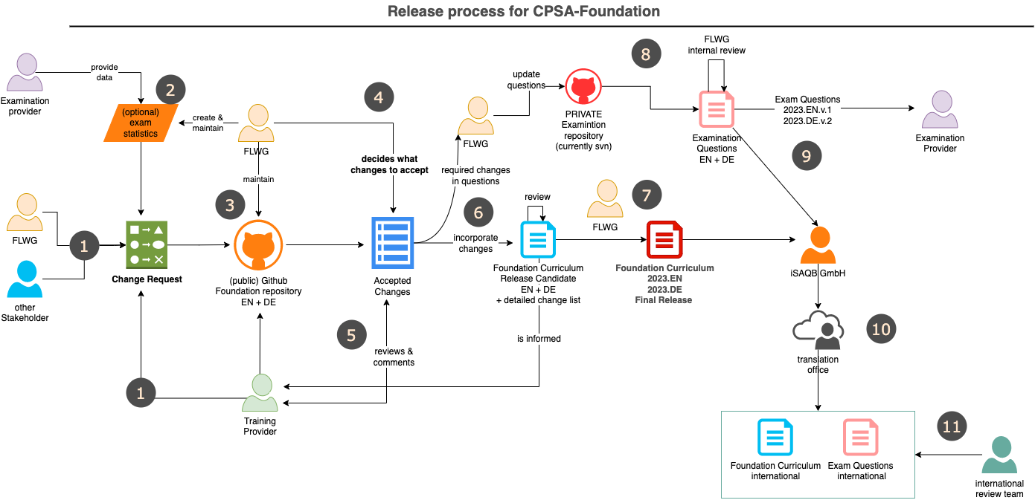](https://github.com/isaqb-org/curriculum-foundation/blob/main/release-process/release-process-2023.drawio.png)

| Nr | Activity | Duration | Schedule/Due-Date |
| --- | --- | --- | --- |
| 1 | Collect change requests | continuously | for 2025, CRs are accepted until May 31st 2024 |
| 2 | We hope to get (anonymous) statistical evaluation of examinations and examination questions from certification providers. | continuously | none |
| 3 | FLWG maintains the curriculum and associated information within this public Github repository |  |  |
| 4 | FLWG decides internally, which changes to accept for the upcoming release. |  | RD - 9M, July 1st 2024 |
| 5 | The list of accepted changes is given to all training providers (TP) for review and request-for-comments. **From that time, TP can begin to update their training material. Several accepted changes are already included in main-branch**. |  | **RD - 9M, July 1st 2024** |
| 6 | FLWG incorporates the accepted changes in main-branch in the Github repo. Contributors from FLWG create understandable commit messages to strive for maximum transparency. **All issues with "accepted" state shall be included until this date.** | 8 weeks | RD - 7M, Sept 1st 2024 |
| 7 | When all changes are included and finalized, a new version of the curriculum is generated (in both EN and DE language) - but not yet made mandatory! All training providers and trainers shall be notified of this update.  **This new version is published as *draft* on the isaqb-org.github.io website.** | 4 weeks | RD - 6M, Oct 1st 2024 |
| 4, 6 & 7 | Minor corrections, hotfixes | continuously |  |
| 8 | FLWG determines which exam questions are affected by the changes in curriculum and updates the exam questions accordingly. Changes to questions are reviewed internally. This will need at least three Independent reviewers | 8 weeks |  |
| 9 | Finalized questions are transformed into pdf/xml and/or other formats, appropriately labelled and securely transmitted to both EP and iSAQB GmbH (to allow translation to languages other than DE and EN) EP need to incorporate this updated version into their examination process and/or toolset until the release date RD. | RD - 3M, Jan 15th 2025 |  |
| 10 | iSAQB GmbH contracts translation of curriculum and questions to translation office (which is under strict nondisclosure agreements) | 4 weeks |  |
| 11 | For every target language there need to be an expert group who can handle review of translation | 4-6 weeks |  |
| 12 | **EN + DE release of curriculum and examination question: Usage of new version is mandatory in all trainings given in DE or EN.**   * **All training providers and trainers need to have their complete training material updated to this release** * **All examination providers EP need to have completed their transition to new questions. Use of old version is NOT permitted from hereon.** |  | **RD, April 1st 2025** |
| 13 | International release of curriculum and examination questions. Usage of new version is mandatory in all trainings given in any language. |  | RD + max 12 weeks |

* **RD**: Release-Date (next: April 1st 2025)
* **EP**: Examination Provider
* **CR**: Change request